Ch. 9 Measuring the STARS

I. Parallax & Proper Motion

A. ___________________ is used to find
distances to the ______________ stars
B. Hipparcos – measured distances to
over 1 _________ stars within _____ l.y.

C. Parsecs
1. The ____________ to a star which
shows a parallax shift of 1 ____ ____
2. 1 parsec (pc) ≈ _____ light years

Parallax Example Problems

1. How far away is *Alpha Centauri in
parsecs at 4.3 light years away?
2. If a star has a parallax of .02”…
a. How far away is it in parsecs?
b. In light years?
3. How far away (in l.y.) is a star
with a parallax shift of .025”?

D. Proper Motion

1. The annual __________ movement of
a star across the sky is called its
proper motion.
2. This is not its ______ motion – only
the ___________ part (not radial part)
Ex/ ____________ ________ (10” / yr. )

II. Brightness

A. Luminosity: ______ energy radiated
by a star each second at all λ’s.
1. a.k.a. Absolute brightness
2. Intrinsic property independent of
a star’s location or observer’s motion.
Ex/

B. Apparent brightness: Amount of
energy per area per unit time
hitting Earth.
i.e. How bright it appears
1. Depends on star’s __________ from us
2. Obeys the ___________ _________ _______
Name ____________________

C. The Magnitude Scale
1. Ranking of ____________
2. Started by Hipparchus -_ categories
3. Lower #’s = brighter objects
4. Each level _____ x brighter. 2.5^{x}
Ex/ Betelgeuse (___), Polaris (____)
5. Can be ____________
Ex/Sirius (_____), Venus (______)
Moon( ),*Sun ( )
6. Naked eye limit: (_); Binoculars( )
7. Absolute magnitude: The star’s
apparent magnitude from a
distance of ___ parsecs. ~___ light yr
a. Distance “ ____________”
b. Ex/ The Sun (* ______ )

Brightness Practice Problems
1. How much brighter is a magnitude
3 star than a magnitude 10?
2. A star 10 light years away is
magnitude 2. How far away is a
similar star (same luminosity) that
is only a magnitude 5?

III. Stellar Temperatures & Sizes

A. Blackbody curves
1. Used to find a star’s _____________
_________________ (& color)
2. The ________ of the curve stays same

B. Spectral Types
1. Based on a star’s __________________
2. O.B.A.F.G.K.M.
Hot ⇒⇒ Cool (*10 subdivisions)
Ex/ Sun (____); Vega (_____);
Betelgeuse (_____)

C. Stellar Sizes
1. _______: Stars 10-100x the radius of
the Sun. Ex/Arcturus (___ R_{SUN})
2. ______________ : Stars > 100 R_{SUN}
Ex/ Betelgeuse (~ _____ R_{SUN})
3. ________ : Stars < radius of the _____
Ex/ Sirius B (.01 R_{S} _______ dwarf)
Proxima Centauri (______ dwarf)
IV. The H-R Diagram

A. _______________ vs __________________

B. Usually, hot stars are _____________.
These are found on the
MAIN SEQUENCE of the H-R
1. Upper left: _______ ___________
2. Lower right: ______ ___________
3. Stars ~.1 - 10 r_{SUN;} .01-100 *M_{SUN}

C. Exceptions to the rule:
a. _____ _________ region (Cool, bright)
b. _________ _______ region (Hot, dim)

V. SPECTROSCOPY - An analysis of
the way atoms absorb & emit light.

A. Spectroscopes
- Barrier w/ narrow slit creates beam of light
- A prism or ___________ __________ separates light into colors.
a. Grating - Transparent sheet w/close, parallel lines
b. Light diffracts thru the openings - rainbow forms
Ex/
3. Eyepiece for viewing
4. Spectrographs/Spectrometers

B. KIRCHOFF’S LAWS

1. German Gustav Kirchoff (1860)
Listed ___ rules of spectroscopy
2. ________, liquids, & dense gases emit
all wavelengths of light - a
continuous spectrum.
a. Full, smooth _____________
b. Humans can see _____- _____ nm
Ex/
3.Emission Spectrum: a low density,
“_____” gas produces emission lines
characteristic of that gas.
a. Narrow, colored lines produced
b. Always the _______ lines for a
particular ______________
c. Like a _________________ for materials
d. Can be used for solids/liquids
e. Pattern - emission spectrum
Ex/ ______ sign, ______ nebula, _________

4. Absorption Lines: A _____, thin gas
absorbs certain wavelengths,
produce absorption lines
characteristic of that gas.
a. Narrow, _______ lines
b. Darkest called ______________ lines
c. Can be produced in a lab
d. Appear in the same position as the
corresponding _____________ lines
e. Produced in space by interstellar
_________, ________, & ____________

5. Astronomy Applications
a. Kirchoff & __________ - spectral lines
are associated w/ known elements
such as _____________
b. In 1868, a previously unknown
element was named after the Sun-

C. Formation of Spectral Lines

1. Electrons only exist at certain
energy ________ or shells
2. Electrons may be “__________” to a
higher level by heat, elec., etc..
3. ______________ is released when
electrons “_____” from this excited
state back to their ground state
4. The size of the energy “______”
directly determines the type of
radiation given off - E = hf
5. Molecules also emit radiation due to
__________ (Infra) or _________ (Radio)

D. Spectral line analysis
1. Spectral Line Strength (__________)
(Brightness or darkness of lines)
a. __________ of atoms of each element
b. Temperature info as well
i. H₂ lines of the “______” Sun are
weak – they’re not excited
ii. Really ____ stars - no H₂ lines at all
- electrons have been stripped

2. The Doppler Effect
a. __________ spectral lines of stars, etc..
b. Used to calculate radial velocity
(along our _______ of __________)
c. _________ shift or ______ shift
Ex/ 420 to 425 nm

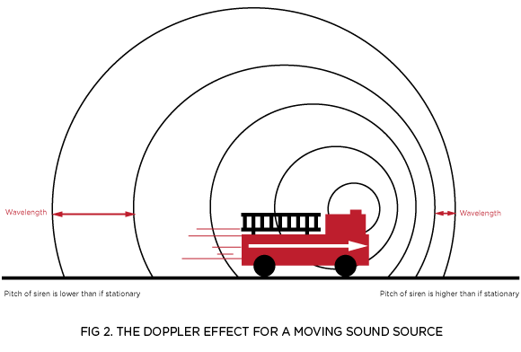

3. Broadening of spectral lines
a. Caused by __________ Effect
b. _______ move toward & away
c. Turbulence of _____ (swirling)
d. _____________ of star, galaxy, etc..

v = f λ

velcocity = freq. x wavelength

4. Zeeman Effect: Presence of strong

_______________ _________ can split lines.

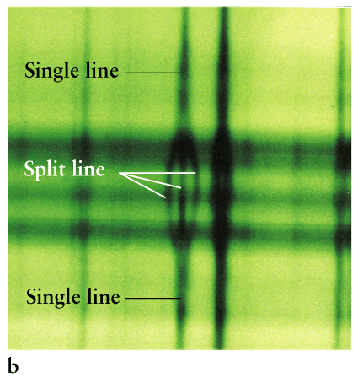

Doppler Example Problem

The 486 nm Hβline of a star is
received at 485 nm.

a. Has it been red- or blue-shifted?

b. What is the frequency of the
original Hβ line?

c. What is the frequency of the
detected Hβline?

d. Is it approaching or receding?

Extra Example Problems

1. At what peak wavelength does a star
with a surface temp. of 5000K radiate?

2. Two otherwise identical bodies have
temperatures of 2,000 K and 16,000 K.
a. Which radiates the most energy?
b. How much more energy?

