Ch 15 Life in the Universe

I. Cosmic Calendar:
The 7 stages in the history of the
universe are particulate,
___________, stellar, ___________,
chemical, ___________, & cultural.

II. The Drake Equation
A. Has no answer –just an _________
1. Divides a large question into a
a series of smaller ones
2. Estimates the number (N) of
advanced civilizations in the
________ ______ today
B. The terms:
1. R* - # of _______ in our galaxy

2. f_{S} - Fraction of ____-like stars

3. f_{p} -Fraction of stars w/ _______
a. At least ___ planet per star
seems likely.
b. Our guess is getting better!

4. f_{E} – Fraction of ________-like
planets per Solar System
a. __________________ is the key
i. _______________ to star
ii. Thickness of ________________
iii. In the habitable zone

b. 1 out of ___ perhaps? More?

c. What is meant by
“Earth-like”?
i. Mars had a warm, wet past
– could there be fossilzed life
in ______________? What about
__________________ microbes??
ii. Europa – ocean ________?

iii. Enceladus - water __________
iv. Titan - carbon, but _______!
Name _________________________

5. f_{L} - Fraction of habitable
planets which have _______
a. Low value: life is ______ or
nonexistent in the galaxy
b. Value of 1: Life is inevitable
given enough time
c. We need more examples!
___________? _______?
d. What is meant by “life”?
No set definition Ex/ _______

e. Typical attributes of life
i. React to their environment
(heal themselves, etc..)
ii. Can ________
iii. Can ________________
iv. Can _________ over generations

f. . A Chemical Evolution for life?
i. Urey-Miller Experiment (1953)
Exposed simple elements to
early Earth-like environment
(___________, “lightning”, etc..)

ii. ________ _______ & complex
organics formed! These are
the building blocks of life!

g. . An Interstellar origin for life?
i. Organics can form in
_____________ __________
ii. __________ contain organics

iii. _________________ have been
found with organics
Ex/ _____________ Meteorite
found w/ ____ amino acids

h. . Alternative biochemistry?
i. Carbon is chemically
flexible, but so is ____________
ii. Water has a wide temp. range as a liquid, but __________ might be used as a medium on a cold planet

6. f_{I} - Fraction of Worlds that
Develop _____________ Life
a. ___________ ____________ would
seem to favor intelligence
b. However, intelligence took
______________ of yrs. to develop
c. We could be the most
intelligent life in the galaxy!

d. Biological evolution was an
incredibly slow process early on
i. 3.5 billion yrs. ago:
Single-celled blue-green ________
ii. 2 billion yrs. ago: ____________
iii. 1 billion yrs. ago: ______________

e. Biological ‘_____ ________’ (570
million years ago –Cambrian era)
i. Number of species exploded
ii. Advantageous traits such as
intelligence evolved
Ex/

7. f_{T} - Fraction of intelligent species
that develop __________________

i. Every isolated ____________
civilization developed tech.
ii. Other life on Earth uses
“technology”, but not radio…
Ex/ Tool usage in ____________
iii. Conclusion: Probably
inevitable

8. L – __________ of technologically-
advanced civilizations
i. _________ - late 1800’s
ii. ___________ power - 1940’s
iii. _________ _________ ________ 1962

III. SETI 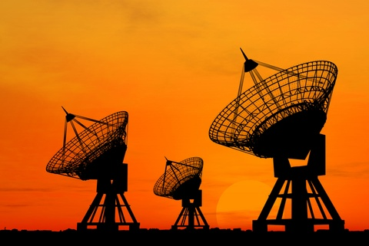

A. The drawbacks
1. Even if there were 1 __________
civilizations in our galaxy, they
would be ______ light years apart

2. Stars too ____ away for travel there
a. ___________ years to Alpha Centauri
b. _______________ yrs. to go 100 l.y.

B. Do we want E.T. to find us?
1. We’re a young, _____________
technological civilization
2. Just in case, we sent a
plaque on Pioneer 10

C. Radio Broadcasts
1. Cheaper, more practical
2. Earth’s radio has reached over
____________ stars (~65 l.y.)
3. The “_________ ________” (H & OH)
4. SETI (Project Phoenix ‘90s)
a. Home-based SETI
b. _______ Telescope Array (ATA)
350 radio dishes

D. The timeline of scientific
achievement & the next great
chapters in the story of
human disovery…
