Ch. 2b Celestial Mechanics

I. Kepler’s Laws of Planetary Motion (Sec 2.4)

A. !st Law –the Law of .

1 Planets orbit the Sun with elliptical
orbits, as do comets, asteroids, etc...
2, The eccentricity of an orbit is a
measure of how -shaped it is.
a. e = 0 indicates a
b. All planets have an orbit w e > 0

B. 2nd Law –Law of Equal .

1. Planets “carve out” equal areas of an
orbit in an equal amount of .

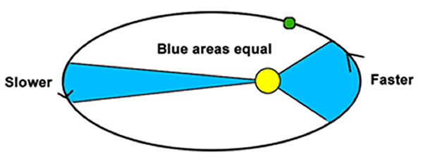

2. For this to be true, planets must
close to the Sun!
3. NASA calls this the
and has
used it on numerous missions such as
Cassini and New

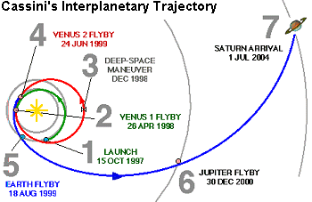

C. 3rd Law – Law of
1. The square of a planet’s period is
proportional to the cube of its *radius
2. The period is measured in
3. The radius is measured in
Name

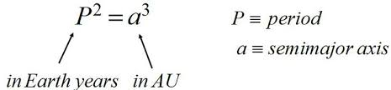

Example Problems:

1. Neptune is 30.6 AU from the Sun.
How many Earth years does it take
Neptune to orbit the Sun?

2. Mars orbits the Sun in 1.87 Earth
years. How far is Mars from the Sun?
Answer:
3. Venus orbits the Sun in 223 days.
How far is Venus from the Sun?
Answer:

II. Newton’s Laws of Motion (2.5)

A. 1st Law- Law of

1. An object at rest will stay at rest
until acted on by an overall force.
Ex/

2. An object that is moving will keep
moving in a straight at
constant until acted on
by an overall force (push or pull).
Ex/

B.2nd Law –Law of

F_{NET} = ma

1. For the same amount of mass,
applying greater Force will result in
acceleration.
Ex/
2. For the same amount of force, greater
Mass will result in
Acceleration.
Ex/

C. 3rd Law - ACTION / REACTION
For every force, there is an
and force.
Ex/

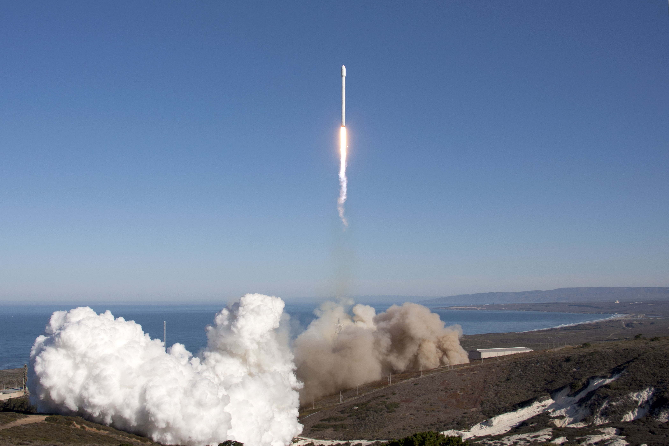

III. Newton’s Law of Gravitation
(Sec 2.6)
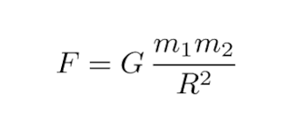
A. The amount of gravity between ANY
objects only depends on their
and the between them.
It is the distance between the
of the 2 objects.
B. The universal gravitation constant,
G, is the same everywhere. It is a
very small number, indicating that
gravity is a very force.
Example Problems

4. If the Earth was the same size as now, but had 5 x its current mass, how would its surface gravity compare to now?

5. If the Earth had its same mass as now, but had 3 x its current radius, how would its surface gravity compare to now?

6. If you fly your spaceship 6 x farther from the center of a planet, by how much would the force of gravity on you ship change?

IV. Acceleration Due to Gravity

A. Newton’s Law of Gravity leads us to
an equation for the rate at which
objects accelerate as they fall.

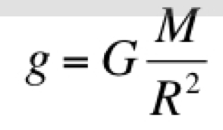

B. “Little g” for the Earth is m/s².
This means that an object’s speed
will increase by about 20 mph for
every second that it falls.
(without air resistance)

Example Problem

7. Calculate the acceleration due to
gravity on the surface of the Moon.
Mm = 7.3 x 10²² kg
Rm = 1700 km
G = 6.67 x 10⁻¹¹

8. Calculate the acceleration due to
gravity 2,000 km above the Moon.

V. Center of Mass

A. Gravity acts as a
force. Ex/ A rock on a string

B. Celestial bodies actually orbit a
common of .
1. If 2 objects are of EQUAL MASS,
then their center of mass will be
exactly halfway between them. They
will both orbit that point in the center
of that system.

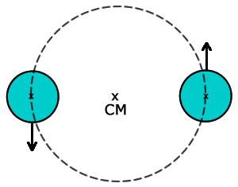

Ex/

2. If the objects are of slightly different
masses, the center of mass will be
closer to the heavier object.

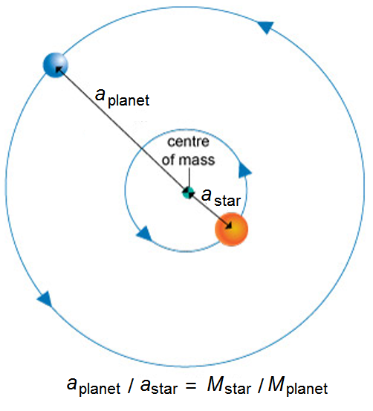
Ex/

3. If the object have very different
masses, the center of mass of the
system may fall the
heavier object.

Ex/

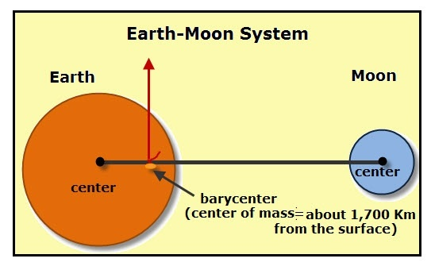

VI. Orbit and Escape Velocity

A. In Newton’s book The Principia, he
amazingly showed how fast objects
would need to be launched to both
orbit the Earth and to escape Earth
all-together. In other words, he
figured out satellites in 1685 (!!).
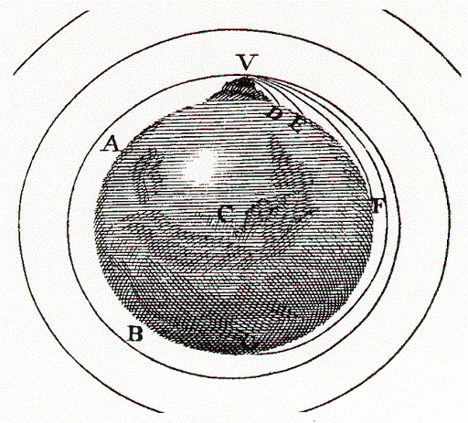

B. Newton derived an equation to
calculate the velocity needed to orbit
any celestial object (Orbital Velocity)

C. For the Earth, the orbital velocity is
mph. This is only for
objects in a nearby orbit – L.E.O., or
Low Earth Orbit.

D. Newton then derived an equation to
calculate the speed needed to escape
any celestial object. (escape speed).
For the Earth, v_{esc} ~ 25,000 mph!
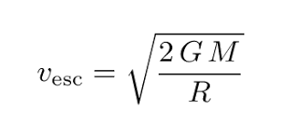
Example Problems

9. What is the orbital velocity of the
Moon?

10. What is the escape velocity of the
asteroid Ceres?

11. What is the orbital velocity of the
Earth at an altitude 5,000 km above
the Earth’s surface?
VII. Microgravity

A. Microgravity is weightlessness due
to . When an
object is falling, it weights nothing!

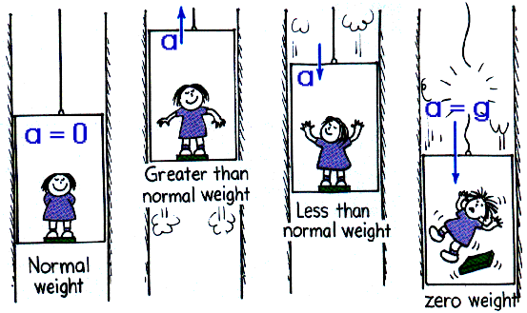

B. A satellite is actually falling – it is
falling the Earth!

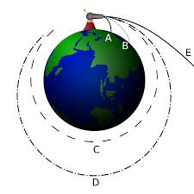

Ex/ High dive demo
Tower of Terror
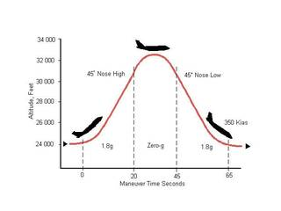

The I.S.S.
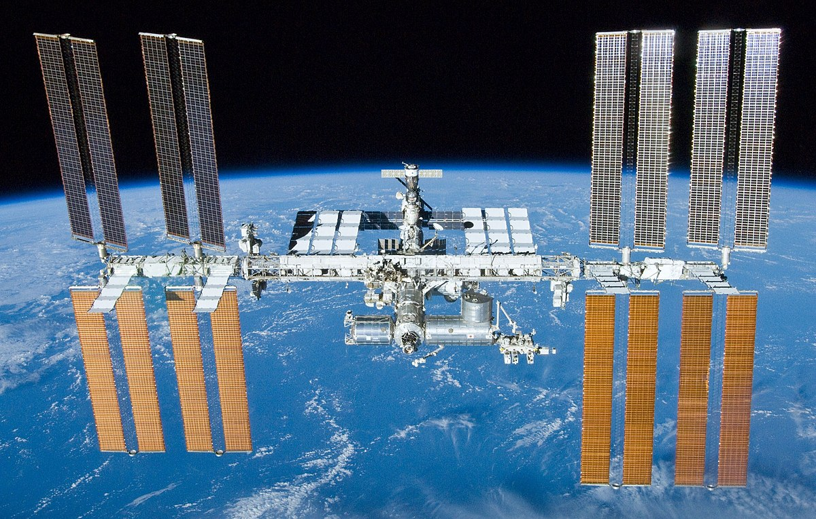

C. Effects of Microgravity

1. Candle flame
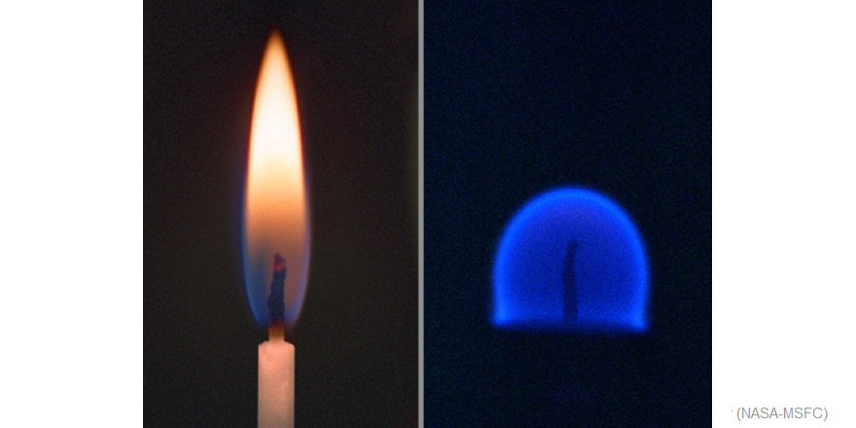

2. Water
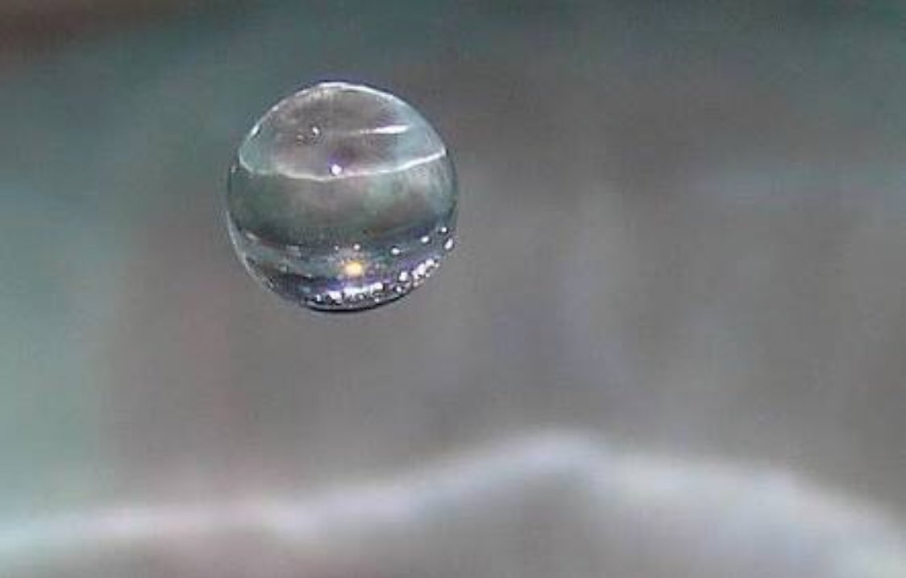

3. People
