Ch. 2 A Brief History
of Astronomy

I. Ancient Astronomy (Sec 2.1)

A. Early Knowledge of the Night Sky
1. The earliest societies of hunters &
gatherers needed to know the
.
2. Later, needed to know
when to plant, harvest, etc...
3. Later still, stars were important for
. Ex/ North star

B. Ancient

1. –
Heelstone marked the Summer
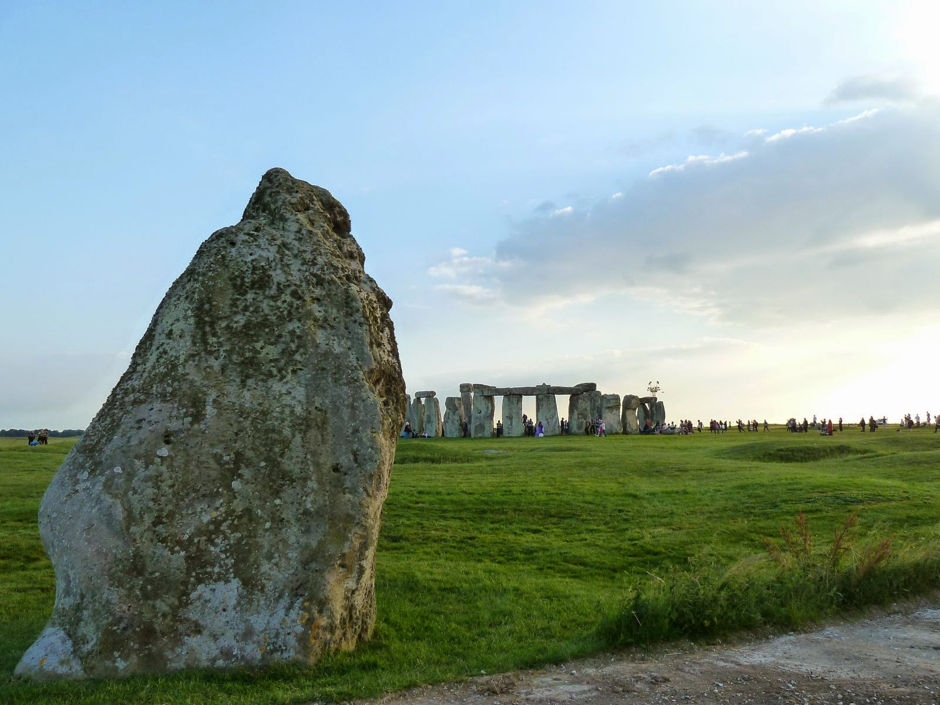

2. Big Horn Medicine Wheel
- North American – Plains Indians
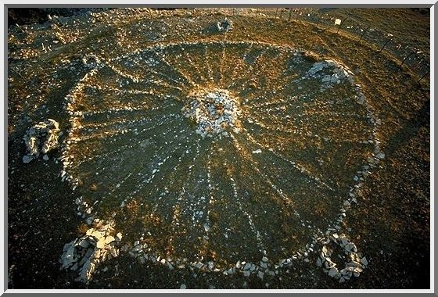

3. Mayan temple
Even tracked (for sacrifices)

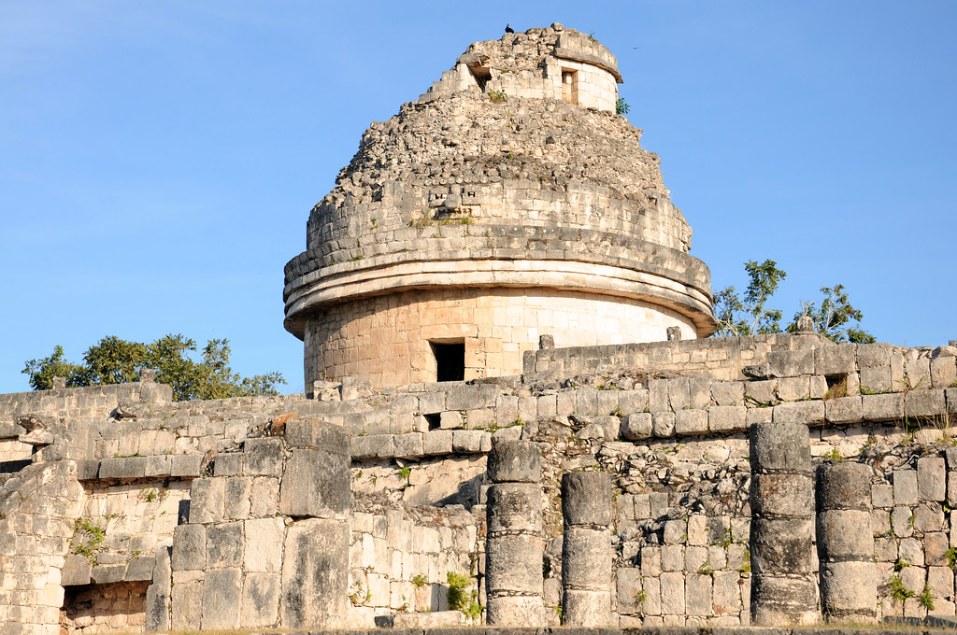

Name

4. Machu Picchu ()

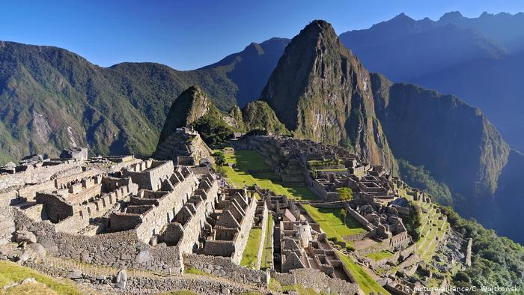

C. Ancient Chinese Astronomers

1. The Chinese kept careful records of
unusual or rare occurrences.
2. "Guest Stars", for example, was
their term for

3. They also tracked .
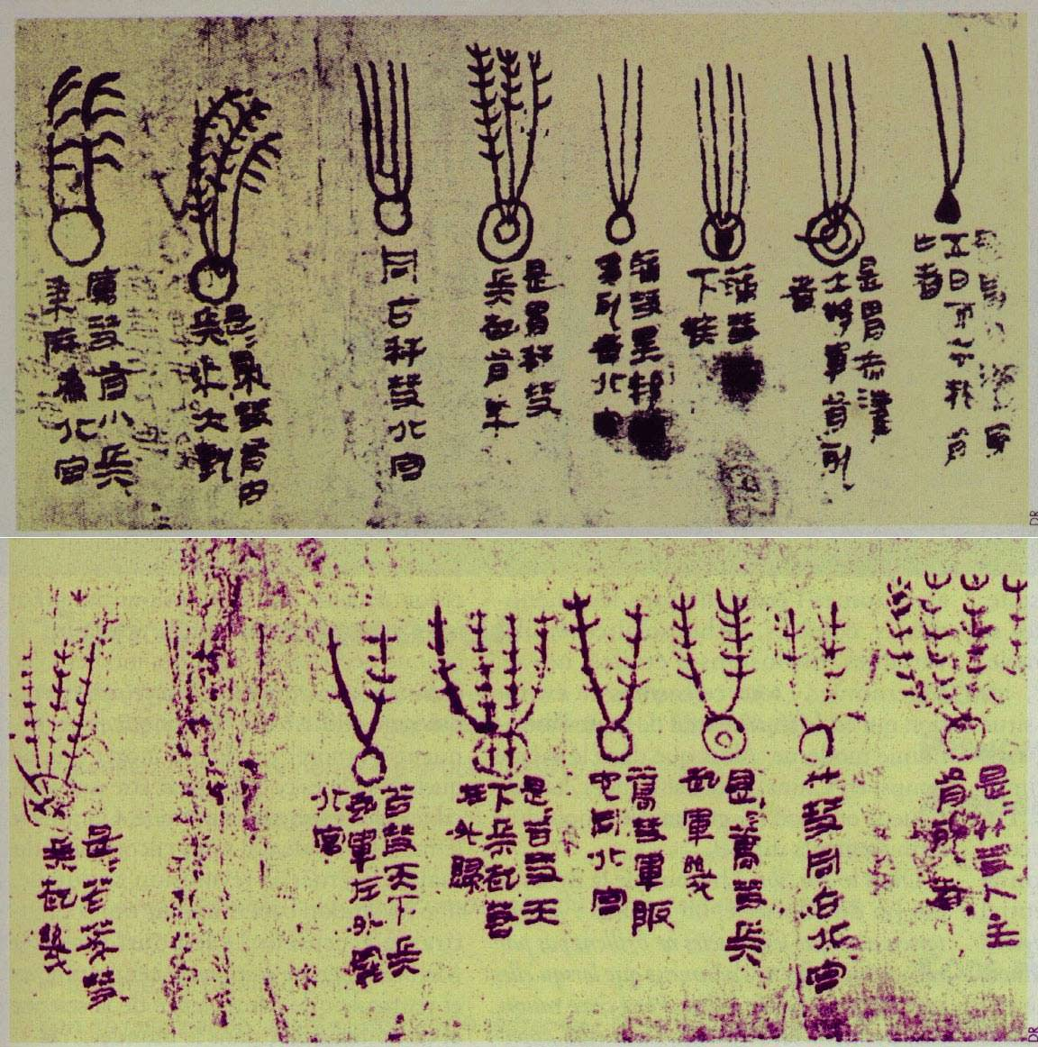

II. Classical Astronomy (2.2)

A. Celestial motion

1. Stars seem to have a
position, so ancient
people could explain them easily.

2. The Sun and Moon have seemingly
orbits and could also
be explained somewhat easily.

3. But the known planets, or
“Planetas”, seemed to wander!

a. Why 7 days of the week?
b. Variable is due to
their varying distance, but the
ancients didn’t understand. But
there was a bigger mystery…
c. Motion: The
apparent motion
of planets in the sky. Ex/Astrology
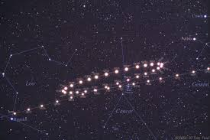

B. Ancient cosmology

1. Aristotle (300's B.C.)
a. Brilliant thinker who supported the
model.
b. And, this philosopher thought
orbits should be !

2. Ptolemy (A.D. 140)

a. Wrote hugely influential book
called Syntaxis, or "The
”

b. He used “ to
explain retrograde motion
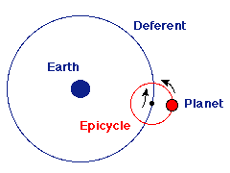

3. Aristarchus (200's B.C.)

a. Proposed a crazy idea – the
theory!
b. Arguments he faced:
i. Earth doesn't seem to
ii. No strong as we orbit
iii. NO detected

Note: This is a perfectly
reasonable argument against the
theory & why it didn’t catch on.

4. The Middle Ages (or “Dark Ages”)

a. astronomy was at
the forefront of math and science.
b. ancient knowledge,
including books such as The
(the Great Book)

c. Arabic
still used today Ex/

III. Birth of Modern Astronomy
(Sec 2.3)

A. Copernicus (1500's)
1. Revived the long-forgotten
theory
2.Why? Because he could explain
motion
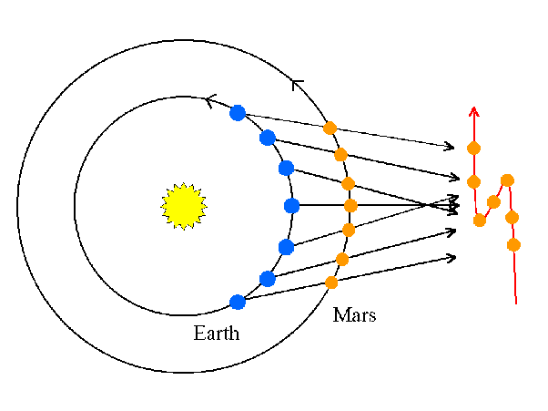
3. Kept orbits, though

4. Books written in only
- "de Revolutionibus" Why?

5. Church, scholars were critical, but
he preferred to than face scrutiny!

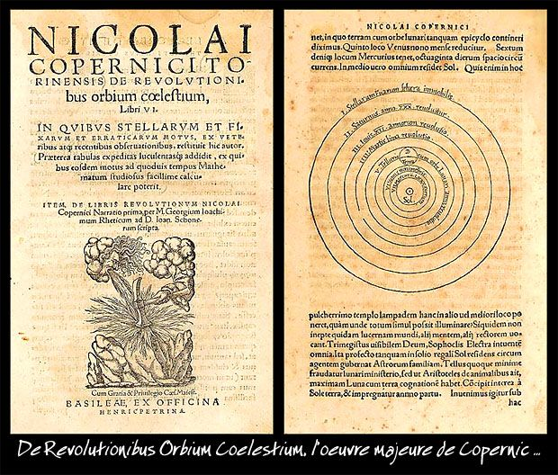

B. Galileo (1564-1642)

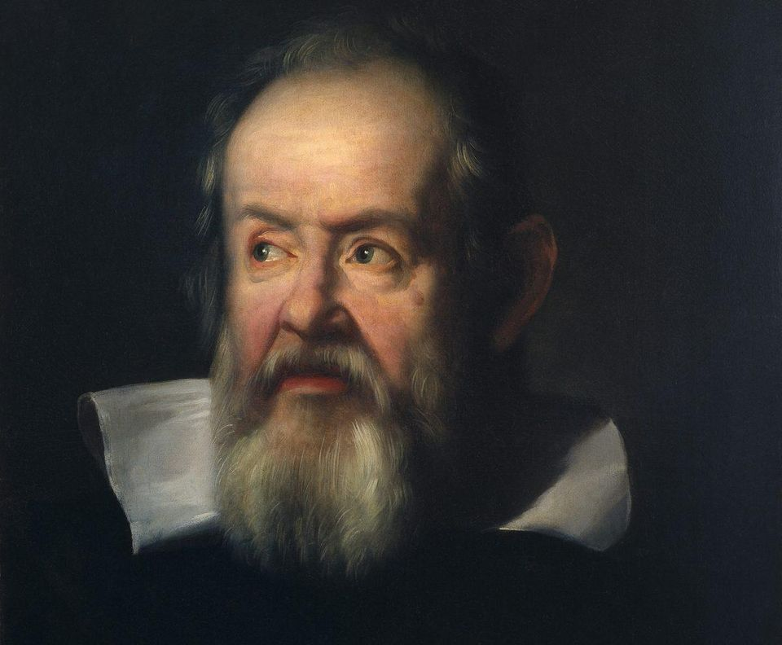

1. Was a modern scientist in that he
conducted .

a. Created
– Study of distance, speed, etc..

b. His most famous experiment
supposedly in town of

c. He showed that *All objects
at the rate

d. The catch – this is true when there
is no resistance. Ex/

2. Embraced
Ex/ Built and used one of the first
Dec. 1609

a. 's craters / mountains
b. First to see !
c. Measured Sun's

*d. Discovered the 4 large moons
and showed they
were not !

e. Observed phases of

3. Book in 1610 - "The
”
4. Later… Church condemnation/trial
a. Giordano (1600)
b. Galileo – House arrest

IV. Laws of Planetary Motion
(Sec 2.4)

A. Tycho Brahe (Late 1500's)
1. Built an
called Uraniborg.
2. Last great naked-eye astronomer
3. Using sextants, etc.. calculated
accurate positions

B. Johannes Kepler (1571-1630) &
his 3 Laws of Planetary Motion

1. Orbits are , meaning they have an eccentricity > 0

2. Planets carve out equal areas in
equal amounts of time (1609)
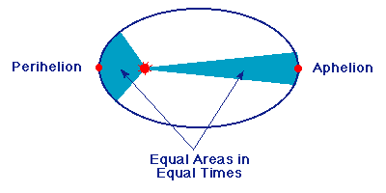
a. Therefore… planets must
near Sun!

b. NASA uses this all the time – it’s
nicknamed The
Effect! Ex/

3. Law of Harmony (1619)

Square of ~ Cube of

T² ≅R³

a. The farther away a planet is, the
longer it takes to orbit the Sun.
b. It’s not the “radius”, but ‘a’

After thousands of years, the model was correct!! But what causes this motion…

V. Newton (*1642-1727) (Sec 2.5)

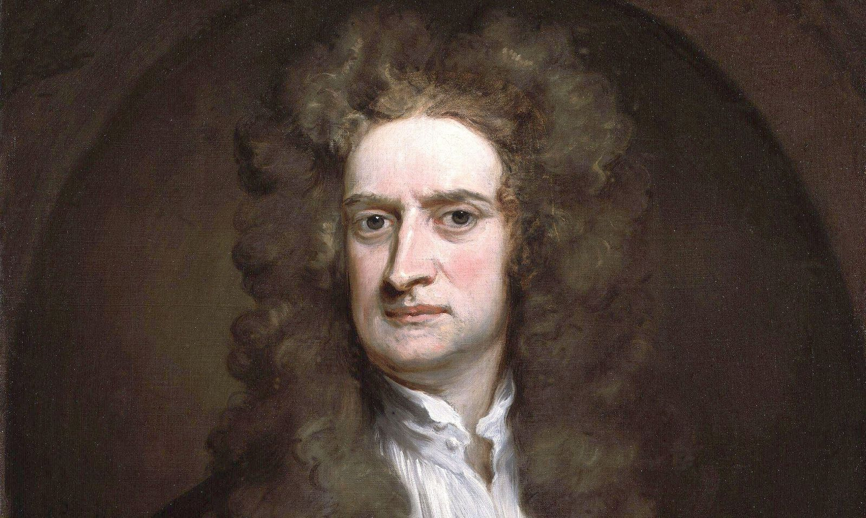

A. Early Years

1. Famously left Trinity College of
Cambridge due to the 1665 plague
2. First related linked a falling
to motion of the Moon.
3. Became a great mathematician and
studied optics and alchemy (oops!)
4. Developed an intense rivalry with
Robert , became a recluse

B. Sir Isaac Changes the World

1. Edmund persuaded
him to write / publish his epic book
a. "The ” 1685
b. Most influential physics book ever

2 Basis for Newtonian
a. 3 Laws of
b. Law of
3. Invented (Leibniz)
4. Invented reflecting

