Ch. 1 Charting the Heavens

I. Our Place in Space

A. Earth is not in any way
B. Most elements came from
Exceptions: , *helium

C. The Universe is !!!!
1. An AU is an astronomical :
Distance from the to the

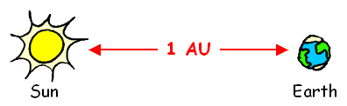

2. A light year is the * light travels in a yr. (6 miles!)

Ex/ How long does it take light to travel..
..from the Earth to the Moon?
..from the Sun to the Earth?
..from the Sun to Pluto? . .from Alpha Centauri to Earth?

II. The Night Sky
A. Basic info
1. We can see about stars w/
the naked eye on a clear night
2. The point directly above
our heads is called the
3. The North Star can be used to find
your
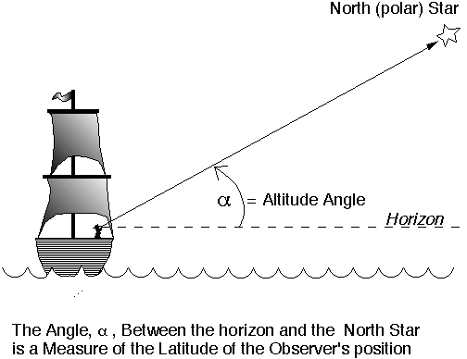
Name

B. Constellations
1. Interpretations of the sky varied by
culture Ex/
2. Stars are not physically
3. Orion’s Belt and the Big Dipper
are examples of

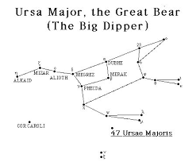
4. Every star is part of one (& only one)
of the constellations
5. Ancient idea that is still useful
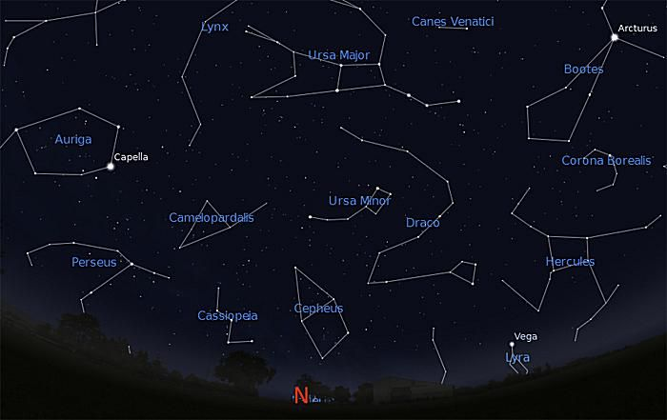

C. Individual stars have been helpful
for navigation, marking yearly
events, etc.. Ex

D. Names of stars
1. Their home
2. Rank of their
Ex/

Greek Letters: Alpha, Beta,
, Delta

E. The Celestial Sphere

1. An imaginary space globe around E
a. Ancient idea (pinholes)
b. Celestial equator; celestial poles
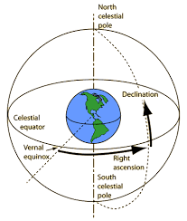
2. Coordinates
a. (latitude)
Measured in

b. ascension (longitude)
Measured in hours, minutes, seconds

III. Earth’s Orbital Motion

A. Motion around Sun

1. Earth moves º
in days, so… ~ ⁰ each day

2. constellations
can be seen all year long
Ex/

The rest are seasonal.
Ex/

3. The : the Sun’s imaginary path through the sky. It’s a line through the sky where all the planets and the Moon are located. It’s where occur!
4. The ecliptic passes through
(actually 13) constellations
collectively known as the
(*not the brightest, oldest, etc..)
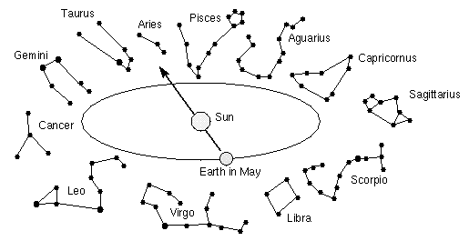

5. Astrology: The that events
in the heavens influence human events
Ex / Your personal horoscope

B. Earth’s ⁰ tilt *know all
1. Causes the
a. Summer, Winter occurs when the Sun’s rays are farthest N and S
b. Fall, Spring
i. Equal and
ii. Sun crosses the
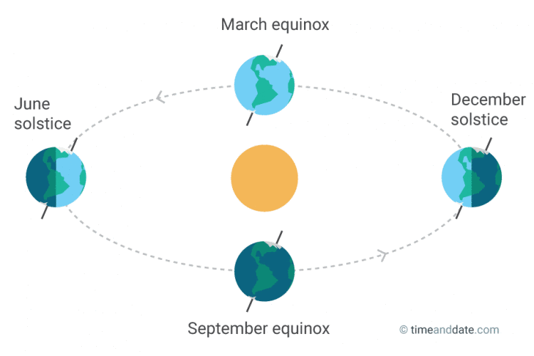

2. of Sun in the sky
3. Length of
4. Position of rising
and setting Sun on the

C. Precession

1. Earth - yr. “wobble”
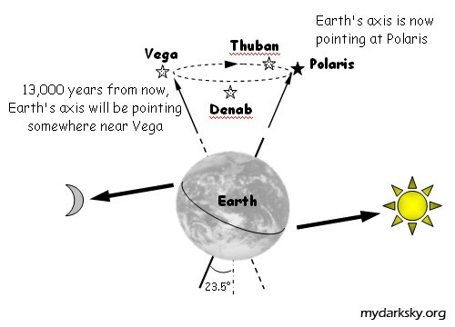

2. Has an effect on our -
months “drift” through
different

3. Star changes over time
Ex/ for the Egyptians

D. 2 Types of “Days”

1. *Sidereal day: Actual time it takes the Earth to spin once- _hrs. min.

2. day (24 hr. day) – the
time from noon to noon.

IV. The Motion of the Moon

A. Phases of the Moon

1. The Moon’s motion in the sky
a. Moon moves its each hour,
or about ⁰ degree (your thumb!)

b. But the Moon appears to move about
degrees per hour due to the

2. Cycle of phases - days
.
3. (grows) and
(diminishes) through…

New, crescent, quarter, gibbous, Full
*New Moon really means Moon!

4. *Sidereal vs. month
a. Sidereal: Actual time for Moon
to circle Earth ( days)
b. Synodic: Time to complete the cycle
of phases (29.5)
c. The difference occurs because the is during that time!
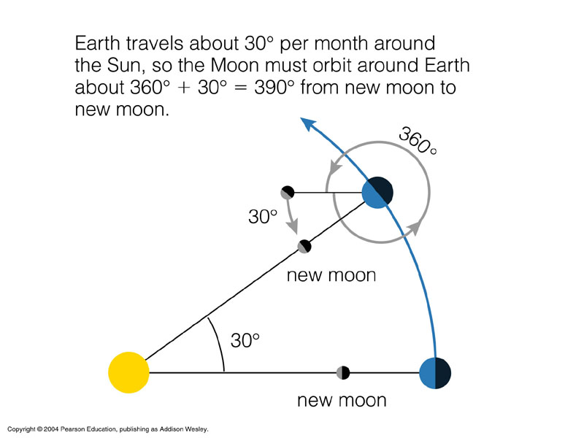

B. Lunar Eclipses
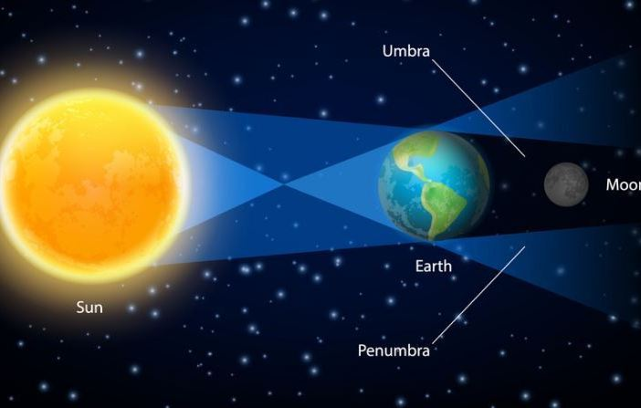
1.Earth’s shadow on a Moon
2.May be partial eclipse if not aligned
3. Entire night side of Earth sees it
4. .Max. time of eclipse: min.
5. tint common. Due to Earth’s
acting as a filter.
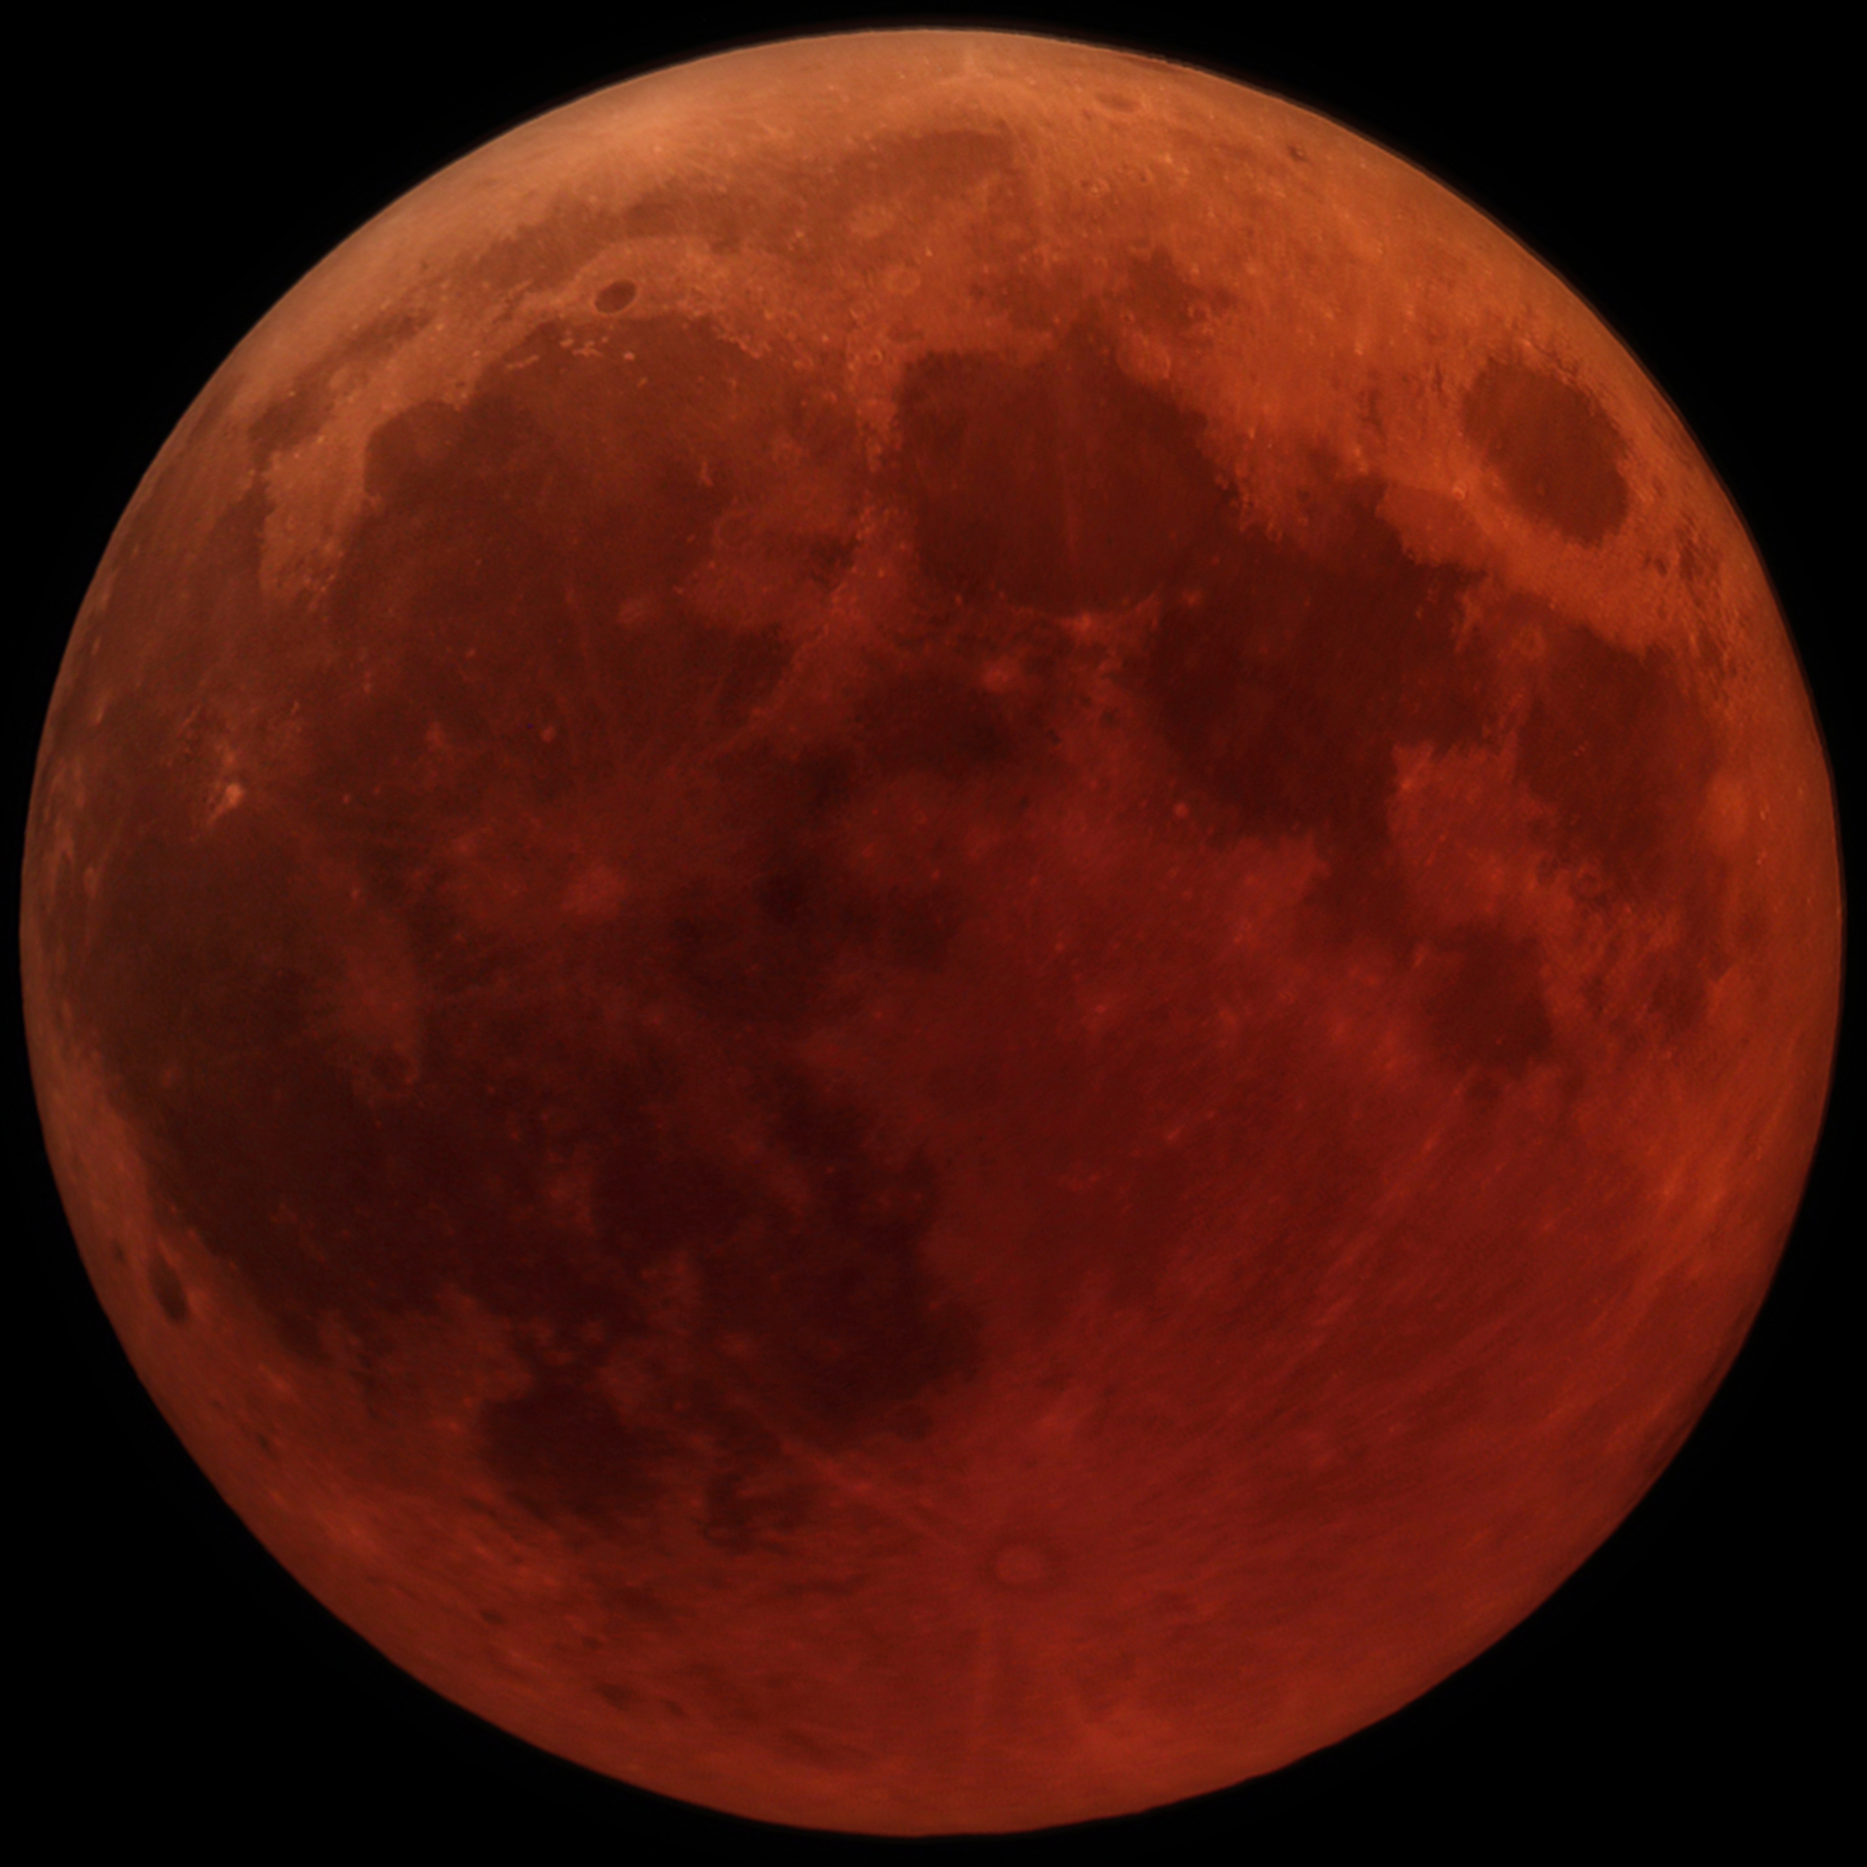

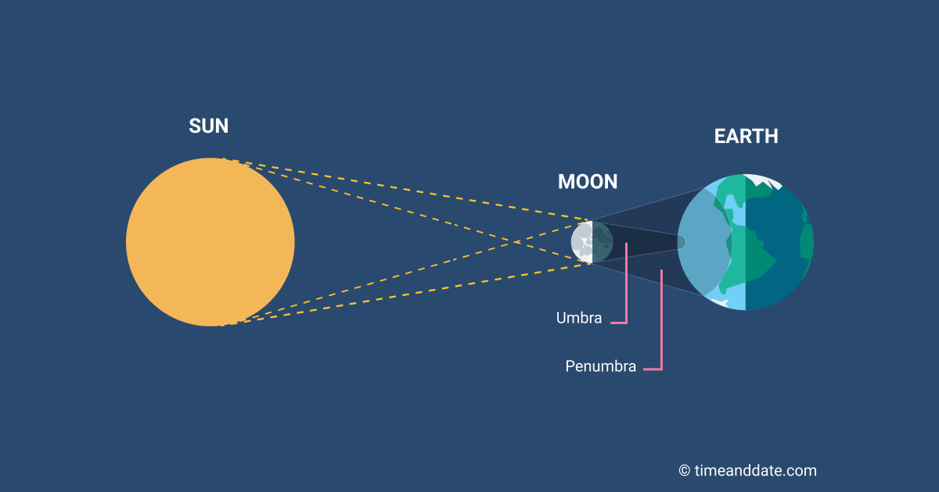

C. Solar Eclipses
1. ’s shadow crosses Earth
2 May see planets, stars in the daytime!
3. Temp. may drop degrees!!
4. Max. time of eclipse: min.
5. Only time the Sun’s upper
atmosphere is visible – the

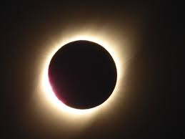

6. Only small swath of Earth sees it.
7. Dark part of shadow (total)
8. :Larger, lighter part
of the shadow (partial eclipse)

9. Sun x larger, but x farther!

10. Annular eclipse: Moon sometimes
too far (at *) and too
small to completely cover the Sun.
(Perigee -closest part of an orbit)
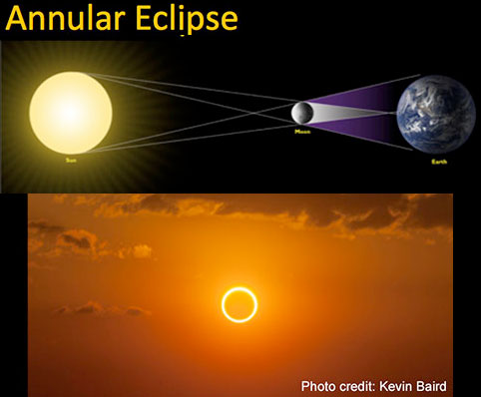
11. Frequency: Every to months
a. Moon’s orbit is by ⁰
b. Eclipses only occur at 2
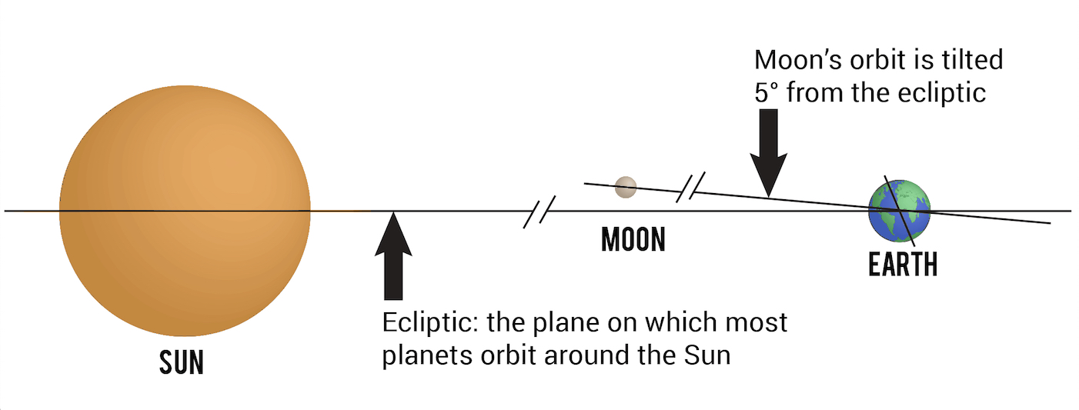

V. Angular Measurements

A. Degree: 180⁰ from horizon to horizon
Ex/ Extended fist: ~ ⁰
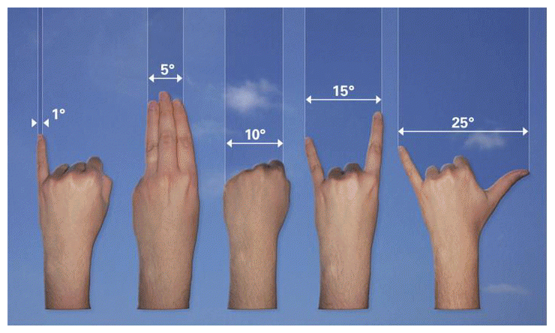

B. Arc : 1/60th of a degree
Ex/ Sun, Moon: ’ or ⁰

C. Arc : 1/60th of arc min.
Ex/ Dime 1 away!

D. Actual &
_matter
Ex/ Coincidence of Sun, Moon

VI. Sizing Up Earth
A. Eratosthenes (Greece 200 B.C.)
B. Accurately estimated
Earth’s !
1. Syene: No shadow at noon on a
particular day in the town well
2. Alexandria: angle of shadow 7.2⁰
3. Ratio gave an estimate of 40,000km
4. Less than % error!!

